Annex E- GEF Data Sheet – Vulnerability context and LDCF additional Reasoning
- Description and context for Intervention sites

- Risk and Vulnerability Profiles of Selected Communities Supported by the AF.
- Sao Tome and Principe has typical characteristics of small island developing stares with high social vulnerabilities mainly due to high poverty rates, small economies sensitive to external economic shocks and highly depend on foreign aid. STP is also exposed to multi-hazards: floods, droughts, coastal erosion, storm surges, and sea level rise. Climate change is exacerbating weather related events. Modeled projections for various scenarios indicate and increase of the extremes for precipitations and droughts for the low- and high-emission scenarios (RCP 4.5 and RCP 8.5 respectively). Temperatures will increase between 2 and 3 degree Celsius for the RCP 4.5 scenario and up to 5 degrees for the RCP 8.5 scenario. Average sea level rise is predicted to increase up to 0.74 cm by the end of the century. Coastal erosion has already caused beaches retreat and sea level rise will increase erosion rates. In this context, extreme and chronic events, mainly revering and coastal flooding and coastal erosion, will severely impact already vulnerable populations.
- The number of people below the poverty line has grown consistently between 1984 and 2001: from 36% of the total population in 1984 to almost 54% in 2001 (Monteiro Fortes, 2011) and 66% in 2009 (CIA World Fact Book). The poverty is unequally distributed, meaning that in some parts of the country the number of people below the poverty line is much more than 66%. Knowing and understanding the local poverty situation is essential when looking into local problems and solutions related to extreme meteorological events and climate change. Unemployment is difficult to measure and probably runs at about 50% (Becker 2008).
- Most vulnerable communities are located along the coast. Some communities, such as Santa Catarina, Praia Cruz, Gambôa, Lochinga, Pantufo e Praia Melao have features more characteristics to urban locations with bigger populations and a more diversified economic activities, with a share of the population working in the capital of Sao Tome. The other communities are more rural in nature, with higher poverty levels and with livelihoods depending mainly on fishery activities, which makes them more vulnerable to the impacts of climate change.
- Table 1 provides some basic population statistics for some of the communities.

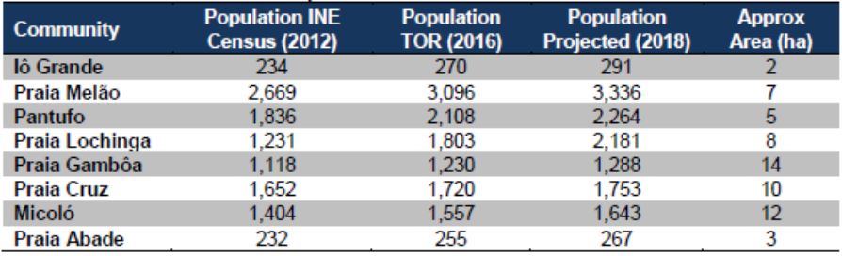
Table 1: Population of some communities for year 2012, population according to the project terms of reference (year 2012), and projected population for year 2018 based on the 2012 and 2016 data. In the last column, the estimated extension of each community is shown.
- To select the communities of the project, a participatory approach has been undertaken combined with information from past events and available risk maps. The selected communities are the ones with higher levels of exposure to floods and with the most vulnerable communities. The AF would allow to expand the support from eight communities to 12 through construction of small to medium flood protection structures including green infrastructure.

- The section below describes more in detail the characteristics of some communities and their risk profile. The case of Io Grande presents a more detail description than the others showing a summary of information available for all communities. For more details for the other communities refer to the study of Deltares, 2019.

- Iô Grande
Site description and aerial view
- Iô Grande is a small village in the southeast corner of São Tomé Island, in the Caué District. Photo 1 depicts the waterfront area at this small site. Figure 2 zooms in and marks important facilities and infrastructure, areas particularly susceptible to natural hazards, and areas of ecological and cultural importance.
- The village is only accessible from the N2 main road, running north-south, followed by an unpaved road. Characteristic features in the village are the primary school near the beach. There are three permanent small kiosks where the community can buy daily household essentials, one healthcare center providing basic attention and first aid, and a small catholic church.
- The population is estimated at 291 people in 2018. This agrees with the estimate provided by the leader of the community (280).
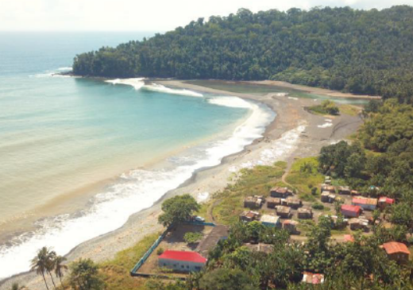 | 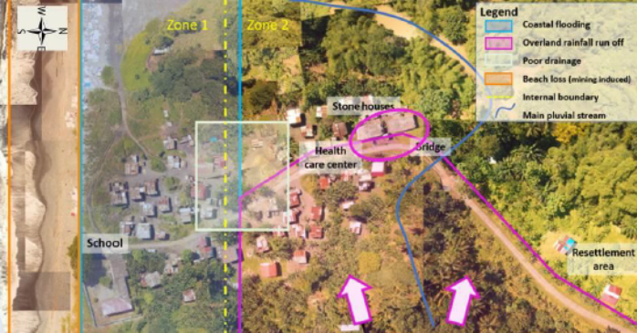
Photo 1 Aerial view of Iô Grande, facing southwest. The community also continues inland, to the right of the photo. Drone image by J. Pronker, CDR International. | Figure 2 Site Map: Iô Grande

- Photo 2 shows the typical houses in Io Grande. In general, all houses have minimum 40 - 50 cm of elevation in poles.

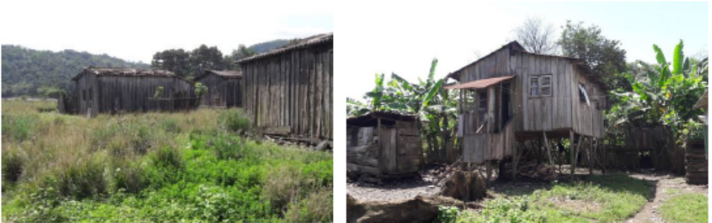
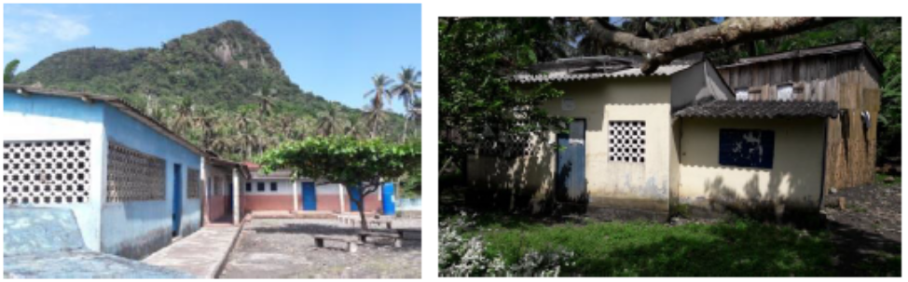
Photo 2: (Above left) Typical ground-level houses near the coast and (Above right) raised wooden houses further inland, in Iô Grande. Photos by B. Ottow. (Below left) primary school and (below right) health care center in Iô Grande. Photos by B. Ottow.

Hazards description
Flooding
- The flood maps in Figure 3 show that the estimated flood depth and extent increases along the small river in the western part of the community. In addition, the southwestern corner experiences an increase in water depth, while the southern part of the community experiences more widespread flooding.
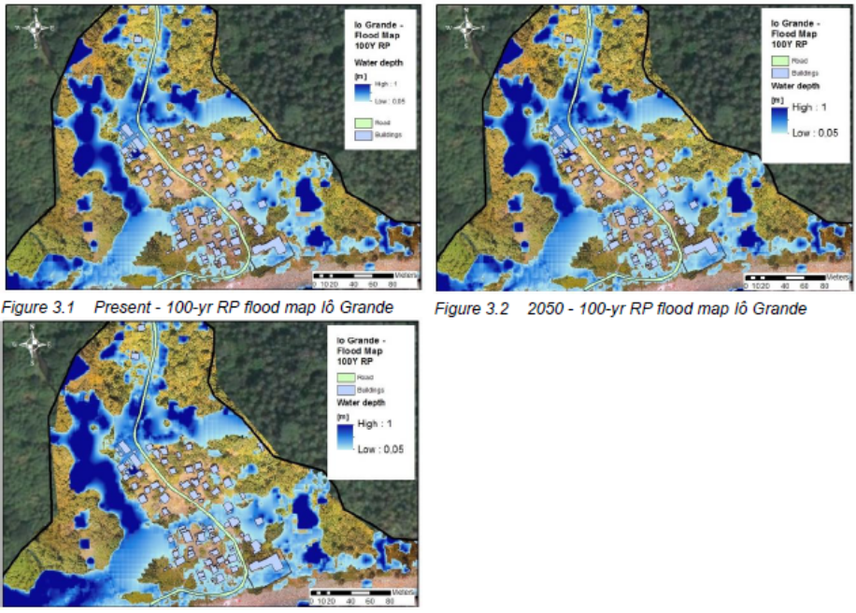
Figure 3: (Above left) Present - 100-yr RP flood map Iô Grande, (above right) 2050 - 100-yr RP flood map Iô Grande, (below left) 2100 - 100 yr RP flood map for Iô Grande.

- Figure 4 shows the risk (Estimated Annual Average Losses - EAAL) per household, per time horizon (present, 2050 and 2100) for Iô Grande, as well as an estimate of the total risk from flooding for the all community. Risks are defined as losses (in STD) per year per household, within different areas characterized by similar hazards (e.g. coastal flooding/rainfall) and/or separated by specific features (e.g. the presence of a road). In the figure direct damages only are shown.
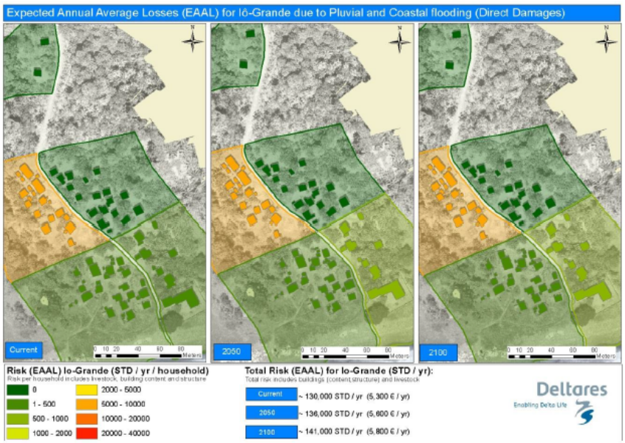
Figure 4: Total EAAL and EAAL per household in Iô Grande, due to direct economic damages only, from pluvial and coastal flooding. The community was divided into 5 regions, using the access road as a dividing line. Risk is computed in 2018 STD and does not take into account socio-economic changes over time.

Combined coastal erosion and flood risk, including socio-economic changes
- Table 2 show the total combined risk in Iô Grande due to coastal flooding, pluvial flooding and coastal erosion, including climate change and socio-economic growth. Damages are expected to increase with both climate change (increase in hazard) and socioeconomic growth (increase in vulnerability) independently, but especially when both occur simultaneously.
- The increase in damages from the present situation to the 2100 situation is of about a factor four when only changes in hazard are considered (scenario 1). When only socio-economic growth is considered, the increase is of a factor 12 (scenario 2), and when both factors are taken into account (socio-economics and climate change) the factor can be up to 50 times.
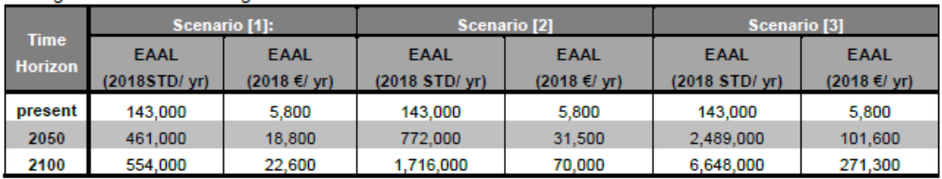
Table 2: Expected annual average losses (EAAL) due to erosion and flooding (coastal and pluvial) in Iô Grande in the present situation, 2050, and 2100, accounting for different scenarios: [1] Risks including change in hazards due to climate change but excluding socio-economic growth, [2]: Risk including socio-economic growth but excluding change in hazards due to climate change and [3]: Risk including both change in hazards due to climate change and socio-economic growth
- Praia Melão
Site description and aerial view
- Praia Melão is located south of the communities of Ghanda and Pantufo and is part of the district of Mé-Zóchi. The village is located in the northeast corner of São Tomé Island, 4.5 km south of the capital. Characteristic features of the village are the football field, the association of fishermen, and the church in the southern part of the village. Photo 3 show aerial views of the community and Figure 5 is a site map, which marks important facilities and infrastructure, areas particularly susceptible to natural hazards, and areas of ecological or cultural importance.
- Praia Melão is located along the secondary road EE103 (INAE). Praia Melão is the most populous of the 12 project sites, with approximately 3096 residents in 2016. With an estimated average annual growth rate of 8% the population in 2018 correspond to a population estimated at 3336. According to women living in the area, woman have 4 to 8 children, so families have approximately 6-10 members who normally live together in the same house (see Photo 4).
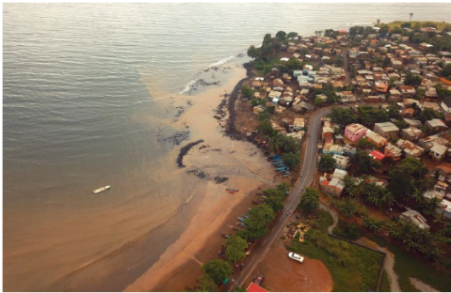 | 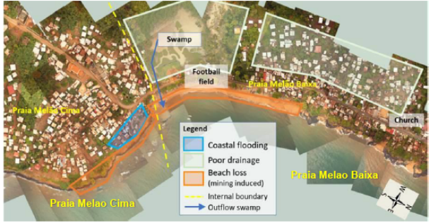
Photo 3: Aerial view of Praia Melão, facing southeast. Drone image by J. Pronker, CDR International. | Figure 5: Site Map: Praia Melão

Hazards description
Combined coastal erosion and flood risk, including socio-economic changes
Table 4 show the total combined risk to Praia Melão due to coastal flooding, pluvial flooding and coastal erosion, including climate change and socio-economic growth. Damages are expected to increase with both climate change (increase in hazard) and socio-economic growth (increase in vulnerability) independently, but especially when both occur simultaneously.
- The increase in damages from the present situation to the 2100 situation is of about a factor 2.5 when only changes in hazard are analyzed (scenario 1). When only socio-economic growth is considered, the increase in risk is a factor 12 (scenario 2), and when both factors are taken into account (socio-economics and climate change) the factor can be up to 28 times.
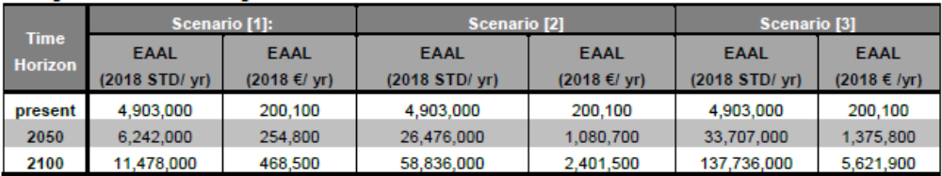
Table 4 Expected annual average losses (EAAL) due to erosion and flooding (coastal and pluvial) in Praia Melao in the present situation, 2050, and 2100, accounting for different scenarios: [1] Risks including change in hazards due to climate change but excluding socio-economic growth, [2]: Risk including socio-economic growth but excluding change in hazards due to climate change and [3]: Risk including both change in hazards due to climate change and socio-economic growth
- Pantufo
Site description and aerial view
- Pantufo is located just south of the city of São Tomé, in Água Grande District, on the northeast coast of São Tomé Island. Photo 5 show an aerial view of Pantufo, facing north while Figure 6 is a site map, which marks important facilities and infrastructure, areas particularly susceptible to hazards, and areas of ecological and cultural importance. The population of the village is estimate to be of 2264 residents in 2018.
- Pantufo is located along the secondary road EE103 (INAE). This road runs parallel to the beach and reconnects with NE2 further to the south. The town is defined by a large square in front of the Catholic church. The town school is located further south, on the landward side of the road, at the border with Praia Melão (outside the borders of the site map).
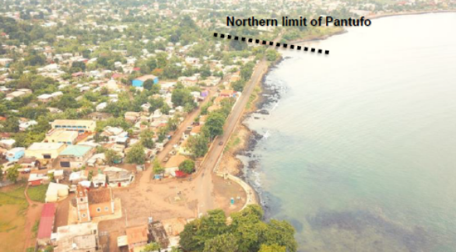 | 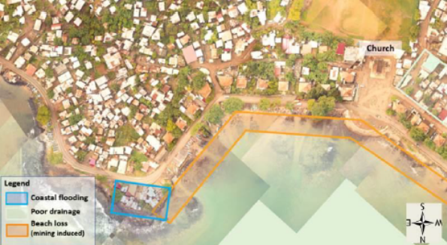
Photo 4: Aerial view of Pantufo, facing north. Drone image by J. Pronker, CDR International. | Figure 6: Site Map: Pantufo

Hazards description
Combined coastal erosion and flood risk, including socio-economic changes
- Table 5 show the total combined risk to Pantufo due to coastal flooding, pluvial flooding and coastal erosion, including climate change and socio-economic growth. Damages are expected to increase with both climate change (increase in hazard) and socioeconomic growth (increase in vulnerability) independently, but especially when both occur simultaneously.
- The increase in risk from the present situation to the 2100 situation is of about a factor 3.5 when only changes in hazard are analyzed (scenario 1). When only socio-economic growth is considered, the increase in risk is a factor 12 (scenario 2), and when both factors are taken into account (socio-economics and climate change) the factor can be up to 40 times.

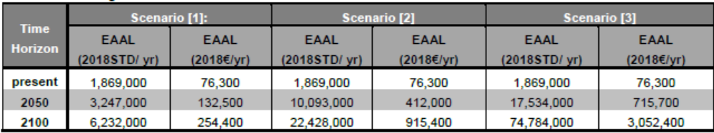
Table 5: Expected annual average losses (EAAL) due to erosion and flooding (coastal and pluvial) in Pantufo in the present situation, 2050, and 2100, accounting for different scenarios: [1] Risks including change in hazards due to climate change but excluding socio-economic growth, [2]: Risk including socio-economic growth but excluding change in hazards due to climate change and [3]: Risk including both change in hazards due to climate change and socio-economic growth
- Praia Lochinga, Gamboa, and Cruz
Site description and aerial view
- Praia Cruz, Gambôa and Lochinga are three adjacent coastal communities between the São Tomé International Airport and the north coast, in Água Grande District. Photo 5 shows two views of the beach. Figure 7 is a site map, which marks important facilities and infrastructure, areas particularly susceptible to natural hazards, and areas of ecological and cultural importance.
- The estimated population in 2018 for all three communities is 5222. The population is skewed young, with women having on average 5 to 8 children, starting at age 15.
- Praia Lochinga (sometimes spelled Loxinga) is the easternmost community, densely developed in the narrow strip of land (~100 m) between the São Tomé International Airport and the sea. There is only one access road (same to access the airport), which ends in Lochinga. Most of the housing is between the road and the sea, while some houses were constructed between the airport wall and the road.
- Praia Gambôa is the community between Praia Cruz and Praia Lochinga. The strip of houses between the main road and the airport is much broader at Praia Gambôa than in Lochinga. At the border between Lochinga and Gambôa, there is a stagnant pond, with an adjacent functioning laundry facility. On the other side of the road are the Pentecostal and Adventist churches. The latter is mainly frequented by people from Lochinga. In the center of Gambôa is a catholic church. Most of the fish from all three communities arrives at Praia Gambôa. The fish market “SãoPaulo” is located next to the beach where the fishermen return with their catch. The fishermen association is located along the main road.
- Praia Cruz is the westernmost of the three communities. The most conspicuous element is the large football field at the west side of the village (Figure 4.8). Further south is the primary school for all 651 children in the three communities (and Diogo Nunes). All the children (100%) attend school, in two shifts each day. Next to the school is the health centre, which serves all four communities. Praia Cruz has its own beach, which is much steeper than the one at Gambôa. At the west end of the community there is a large pond that a Chinese project attempted to use for fish breeding.
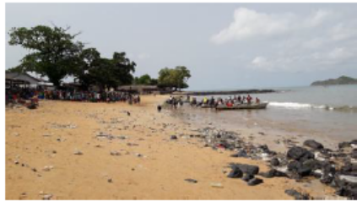  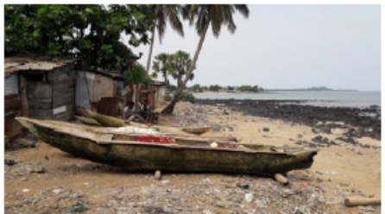 | 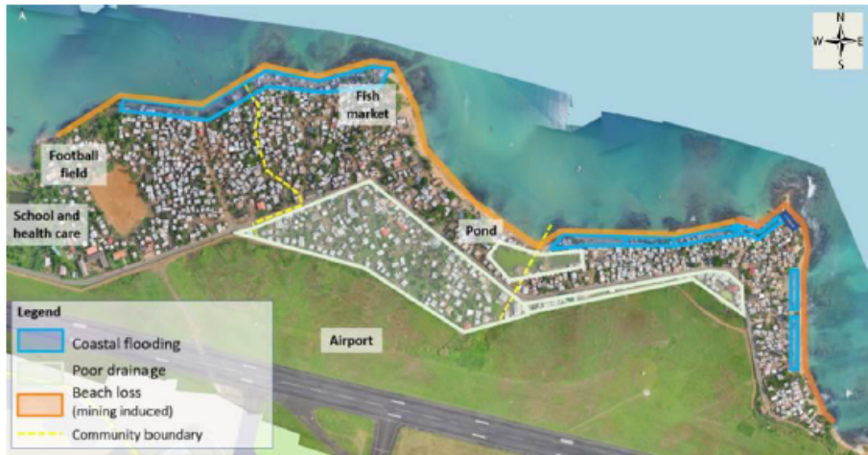
Photo 5: The beaches of Lochinga (top) and Gambôa (low). | Figure 7: Site Map of Praia Cruz, Gambôa, and Lochinga, with drone image courtesy of CONPREC, OLA, and SNPCB (2018).

Hazards description
Combined coastal erosion and flood risk, including socio-economic changes
- Table 6 show the total combined risk to the Airport region due to coastal flooding, pluvial flooding and coastal erosion, including climate change and socio-economic growth. Damages are expected to increase with both climate change (increase in hazard) and socio-economic growth (increase in vulnerability) independently, but especially when both occur simultaneously.
- The increase in damages from the present situation to the 2100 situation is of about a factor 2 when only changes in hazard are analyzed (scenario 1). When only socio-economic growth is considered, the increase in risk is a factor 12 (scenario 2), and when both factors are taken into account (socio-economics and climate change) the factor can be up to 26 times.
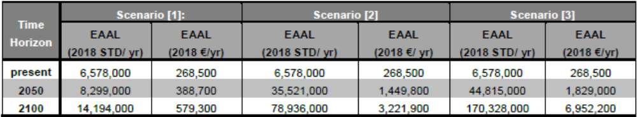
Table 6: Expected annual average losses due to erosion and flooding (coastal and pluvial) in the Airport region in the present situation, 2050, and 2100, accounting for different scenarios: [1] Risks including change in hazards due to climate change but excluding socio-economic growth, [2]: Risk including socio-economic growth but excluding change in hazards due to climate change and [3]: Risk including both change in hazards due to climate change and socio-economic growth.

- Micoló
Site description and aerial view
- Micoló is a town on the north coast of São Tomé Island, in the Lobata District. Photo 6 show two aerial views of the community. Figure 8 is a site map which marks important facilities and infrastructure, areas particularly susceptible to natural hazards, and areas of ecological and cultural importance.

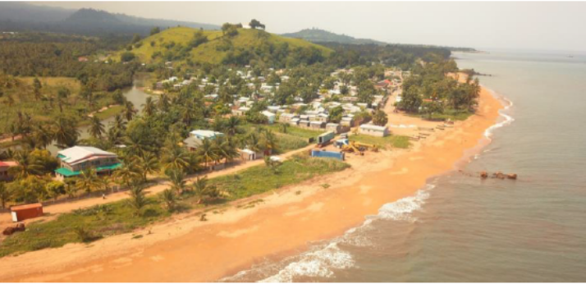
Photo 6: Aerial view of Micoló, facing west. Drone image by J. Pronker, CDR International.
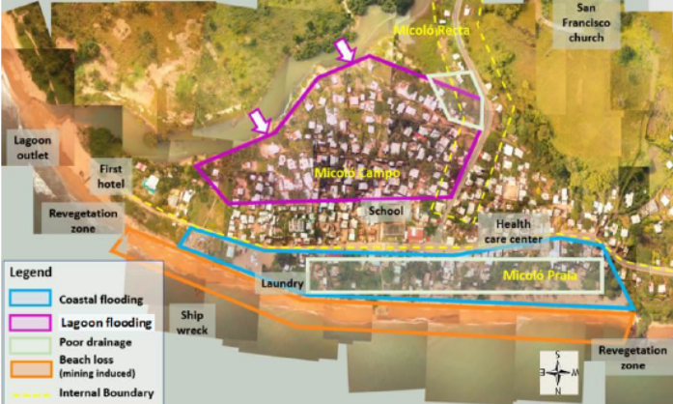
Figure 8: Site Map: Micoló

- In 2012, the population of Micoló was 1404 people plus 431 people living in the area of Micoló Recta (INE, 2012). The estimated population for 2018 is of more than 2000. Households have between 4 and 10 members. Women normally start having children around the age of 16. The general perception of the population establishes that there are more women than men (60% women and 40% men).
Hazards description
- Table 7 show the total combined risk to Micoló due to coastal flooding, pluvial flooding and coastal erosion, including climate change and socio-economic growth. Damages are expected to increase with both climate change (increase in hazard) and socioeconomic growth (increase in vulnerability) independently, but especially when both occur simultaneously.
- The increase in damages from the present situation to the 2100 situation is of about a factor four when only changes in hazard are analysed (scenario 1). When only socio-economic growth is considered, the increase in risk is a factor 12 (scenario 2), and when both factors are taken into account (socio-economics and climate change) the factor can be up to 50 times.

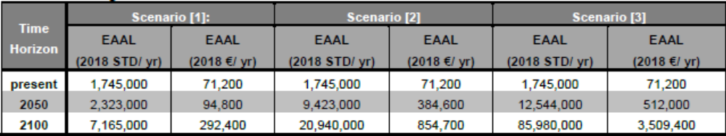
Table 7: Expected annual average losses due to erosion and flooding (coastal and pluvial) in Micoló in the present situation, 2050, and 2100, accounting for different scenarios: [1] Risks including change in hazards due to climate change but excluding socio-economic growth, [2]: Risk including socio-economic growth but excluding change in hazards due to climate change and [3]: Risk including both change in hazards due to climate change and socio-economic growth

- Praia Abade
Site description and aerial view
- Praia Abade is located in the Autonomous Region of Príncipe on the east side of the island, 7 km from the capital, in a small pocket beach in a very sheltered cove. Photo 7 captures the coastline of the community. Figure 9 is a site map, which marks important facilities and infrastructure, areas particularly susceptible to natural hazards, and areas of ecological and cultural importance.
- The community has only one dirt access road, which is currently undergoing upgrades. There are few houses between the beach and the road. The majority of the population lives on the landward side of the road (including the health care center, kindergarten, and school).
- Population estimates indicate approximately 268 residents in 2018. In this region, households have 6 to 10 members. The general perception of the population establishes that there are more men than women (60% men and 40% women).

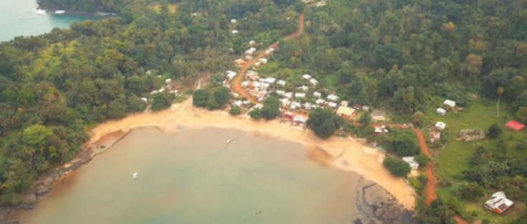 | 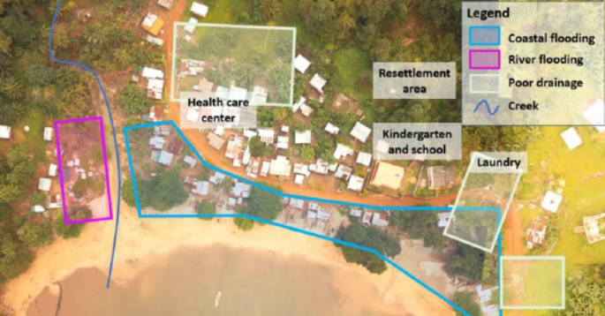
Photo 7: Aerial view of Praia Abade, facing east. Drone image by J. Pronker, CDR International. | Figure 9: Site Map: Praia Abade

Hazards description
- Table 8 show the total combined risk to Praia Abade due to coastal flooding, pluvial flooding and coastal erosion, including climate change and socio-economic growth. Damages are expected to increase with both climate change (increase in hazard) and socio-economic growth (increase in vulnerability) independently, but especially when both occur simultaneously.
- The increase in damages from the present situation to the 2100 situation is of about a factor 2 when only changes in hazard are analyzed (scenario 1). When only socio-economic growth is considered, the increase in risk is a factor 12 (scenario 2), and when both factors are taken into account (socio-economics and climate change) the factor can be up to 24 times.

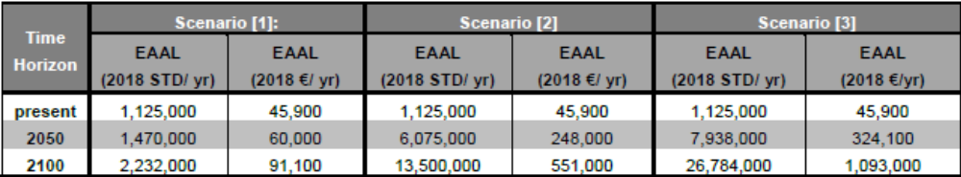
Table 8: Expected annual average losses due to erosion and flooding (coastal and pluvial) in Praia Abade in the present situation, 2050, and 2100, accounting for different scenarios: [1] Risks including change in hazards due to climate change but excluding socio-economic growth, [2]: Risk including socio-economic growth but excluding change in hazards due to climate change and [3]: Risk including both change in hazards due to climate change and socio-economic growth

- Map Location of communities supported by the WACA ResIP including the AF
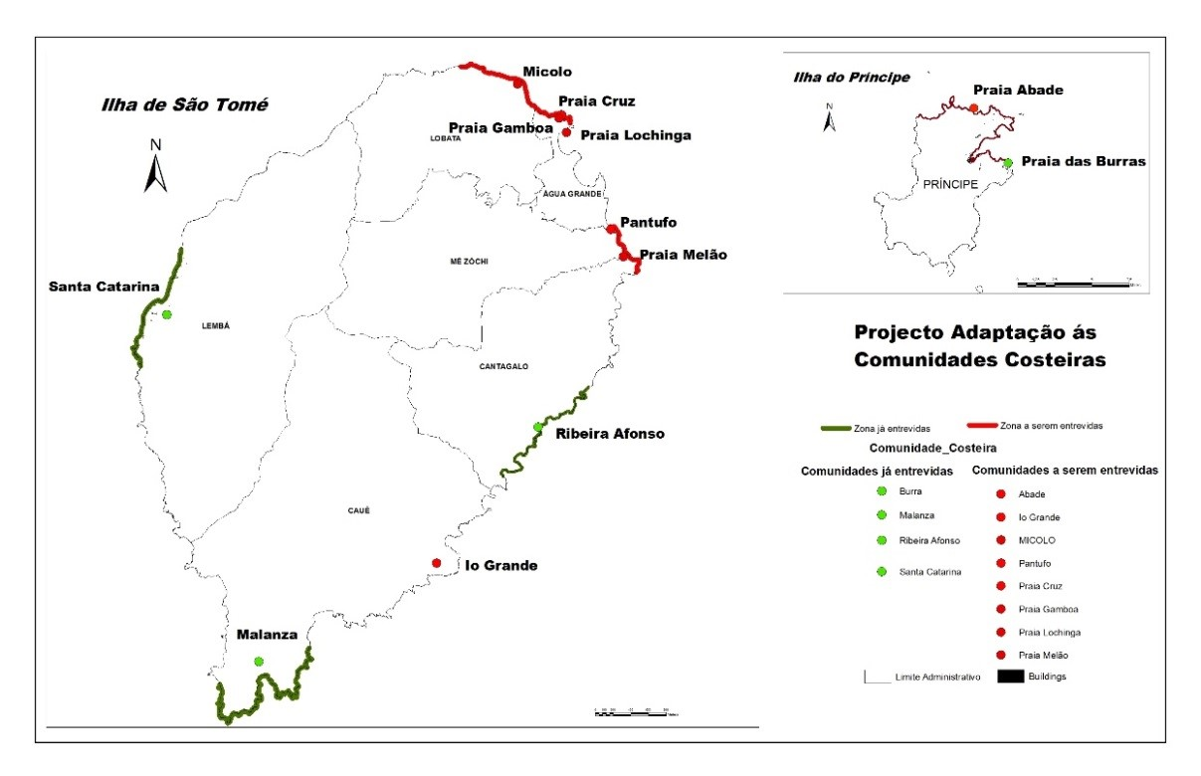

- LDCF Additional Reasoning

- During the preparation of the Parent Project, WACA-ResIP, a set of activities were identified for a total budget of US$ 15.15 million. While US$8.0 million were available from IDA and US$ 1.15 million from the International Water Window of the GEF, a US$ 6.0 million proposal was submitted to the GEF secretariat to finance, from the Least Developed Countries fund (LDCF) the activities proposed under this Additional Financing (AF). This AF aims to scale-up the development impact of the parent project in São Tomé and Príncipe by implementing activities embedded and envisaged in the planning phase of the Parent Project, but not yet financed.
- The Parent project, WACA ResIP, emphasizes the development of safer relocation areas to provide incentives for the population not to settle in the most at-risk areas, but additional investments are needed to restore the natural ecosystems so that they could play their original role of adaptative protection from tides, surges and sea-level-rise; and to develop them to promote community-based sustainable income generating activities, such as tourism and sustainable fisheries.
- As designed, activities under this AF will scale-up risk mitigation and adaptation measures from eight to 12 of the most vulnerable communities following the Parent Project participatory approach. Activities under the AF will complement planned relocation with scaled-up risk mitigation measures and ensure that the to-be vacated areas are properly planned to ensure their long-term sustainability and avoid future re-settlements in these as risk areas. The process of helping the pilot communities expand into safer areas may be shortchanged if the to-be voluntary vacated areas would not be restored and properly planned and used for sustainable and resilient uses. Also, additional adaptation measures will be needed to protect the rest of the communities, to the threat of climate change, through improvement of the drainage system.
- The AF would also help to improve the early warning and safety at sea amongst artisanal fishers, and thus ensure that lives can continue to be saved over the long term. Principles of safety at sea would have been introduced amongst part of the coastal fishermen - with an immediate observable impact - but with uncertain sustainability due to the time required to change risk behavior. The AF will also expand the outreach of the safety at sea program from 1750 to now 4,155 artisanal fishers (all identified artisanal fishermen in the country) and improve the early warning system component of the project by complementing the weather forecast with two additional marine meteorological stations.
- Given that such activities represent a natural complement to the parent Project WACA-ResIP activities, AF seems the most appropriate option to maximize development outcomes. The project will enable a faster and more cost-effective response to the client’s request to sustain and scale-up the results. The responsible agency, Directorate General of Environment, Ministry of infrastructure, Public Work, Natural Resource and Environment, has demonstrated its strong commitment, and has proved to be a competent counterpart agency, as shown by the initial project’s satisfactory track records. There would be no change to the key implementation arrangements put in place.
- The AF would contribute to Climate Change Adaptation (CCA) objectives “Reduce vulnerability and increase resilience through innovation and technology transfer for climate change adaptation” (CCA-1) of the GEF/LDCF Focal Areas. The AF would serve as a pilot case for the implementation of solutions tailored to the needs and the contexts of the Small Islands States, to adapt to climate change and build resilience to disaster risk in their coastal areas.

- Project Baseline and Coordination with Other Activities

- While the AF will be processed linked to the baseline WACA project, it will leverage new and additional co- financing as detailed. A substantial part of the co-financing (estimated at US$200,000 per district, or a total of US$1.4 million) is the expected in-kind counterpart contribution from the seven participating districts, to fund maintenance activities in the target communities and social developments in the expansion areas. Evidence from the first project indicates that this is already happening – in Malanza, for example, the Government installed electricity in the expansion area and is planning the construction of a new school. In addition, São Tomé and Príncipe has established community based risk management committees in the targeted villages, whose role is to organize maintenance activities, as well as encourage adaptation and risk reduction. The expected end result is that all districts in São Tomé and Príncipe will have gained experience from incorporation of adaptation and risk‐based management into participatory local development plans, and that the model can then mainstreamed nationwide.

- Also, in Agua Grande District, an infrastructure project, jointly financed the Dutch cooperation program DRIVE and the European Investment Bank, will build coastal protection works (sea wall, rock revetment and beach nourishment) for an estimated amount around US$6 million, between the proposed project intervention sites from Praia Gamboa (airport) to Pantufo. These activities provide geographical complementarity and contiguity in the measures taken for coastal protection and strengthening to link the rural and urban coastal segments. LDCF support will cover the green infrastructure elements in synergy with the IDA supported grey infrastructure investments. The project is also implemented by the DG Environment; therefore coordination will be ensured both at project implementation and at technical level.

- Also, the government of São Tomé and Príncipe, with support from IDA, is implementing a project to develop the transport sector, with a special focus on strengthening its resilience to climate change and protecting the transport from coastal risk. The project will train staff of the national Institute for road, as well as the community-led maintenance groups (“GIMEs”), to monitor and implement, coastal protections, using locally available material and equipment. The project will pilot small scale interventions, for a total co-contribution of 1.0 million (technical assistance and small works).

- In addition to the WACA baseline project of this proposal, several LDCF-financed projects dedicated to the building of climate resilience in São Tomé and Príncipe, are currently under implementation or under preparation as below.
- Enhancing capacities of rural communities to pursue climate resilient livelihood options in the Sao Tome and Principe districts of Caué, Me-Zochi, Principe, Lemba, Cantagalo, and Lobata (CMPLCL) (GEF ID: 5184, UNDP) – on-going
- Strengthening Resilience and Adaptive Capacity to Climate Change in São Tomé and Príncipe’s Agricultural and Fisheries Sectors’ (GEF ID: 9113, AfDB) – on-going
- Landscape Restoration for Ecosystem Functionality and Climate Change Mitigation in the Republic of Sao Tome e Principe (GEF ID: 9517, FAO) – project approved
- Enhancing Biodiversity Conservation and Sustainable Land and Natural Resource Management (GEF ID:10007, UNDP) - Concept Approved

- The project is aligned and coordinated with these different initiatives to ensure the most appropriate synergies and avoid duplication. Having the National Committee for Climate Change, as the technical advisor committee for the WACA ResIP project, but also involved in the different initiatives, ensures the transfer and exchange of information with the other initiatives.

- Even if the first UNDP-implemented (GEF ID: 5184) project in the list focuses on in-land communities, the WACA ResIP, will benefit from its experience. Due to this geographical distribution, there will be no overlapping of activities, but the successful experience to enhance capacities of rural communities will be considered in the development of the at-risk areas, to promote activities for the communities which will help their development while ensuring that the at-risk areas are occupied in a sustainable and resilient way.
- AfDB-implemented project (GEF ID: 9113) focuses on fisheries infrastructure development and reinforcement and is thus complementary to the proposed project. The proposed project will draw synergies with these ongoing activities. A coordination mechanism has been established, though the implementing agencies (D. Fisheries and Ngo MARAPA) to align the construction of their infrastructures with the adaptation plans developed by the communities for the WACA ResIP project. Also, data on fishermen and canoes are shared, and the plan to distribute equipment (safety at sea for WACA ResIP, and fishery for AfDB project) and train the fishermen are coordinated.
- The FAO-implemented project (GEF ID: 9517) has started recently. It aims to restore different ecosystems in STP, to capture carbon, but also to build the resilience of the islands to the impacts of climate change. In particular, they will pilot and expand efforts to restore and manage mangroves (both in Principe and in São Tomé), which will protect, from coastal erosion and flooding, coastal zones not covered by the WACA ResIP project. The projects will collaborate, especially through the directorate of forest, to make sure that ecosystem restoration in both projects benefit from each other, both through geographical connection and repartition, but also through experience sharing and capacity built.

- The last UNDP-implemented project (GEF ID:10007), under preparation, will have a significant positive impact on the proposed WACA ResIP project. They aim to develop the first marine protected area, which will help to structure the management of the coastal zone in São Tomé and Principe. Collaboration will be crucial, through common executing agencies (D. Fisheries, D. Environment, IMAP), to ensure alignment between the spatial marine plan to be supported by this proposed project and the definition of the marine protected areas.

- Long-term Sustainability of Interventions

- Activities are designed and planned with long-term sustainability in mind. The participatory approach that is used along the identification of vulnerable households, consideration of risk perceptions by local population. Maintenance of works by local authorities is intended to ensure long-term sustainability. Regular consultations and involvement of local leaders and beneficiaries as well as national institutions help to create ownership of the project by local population and national institutions.

- Local authorities will be involved in the construction and maintenance of flood protection works ensuring longer durability of works. Local authorities and population will also be trained on maintenance techniques. Protection works will be built with local material and designs will be simple and easy to replicate. The expected in-kind contribution from the participating districts is to fund maintenance activities in the target communities and social infrastructure in the expansion areas. Evidence from the previous adaptation project indicates that this is already happening – in Malanza, for example, the Government installed electricity in the expansion area, while in Praia Abade, the Region managed to obtain the construction of a school in the safer area. In addition, São Tomé and Príncipe has established community-based risk management committees in the targeted villages, whose role is to organize maintenance activities, as well as encourage adaptation and risk reduction.

- The expected end result is that all districts in São Tomé and Príncipe will have gained experience from incorporation of adaptation and risk‐based management into participatory local development plans, and that the model can then mainstreamed nationwide.
- Under the Early Warning and Safety at Sea Component, the last mile communication protocols designed under the parent project (radar detection, community radio, and FrontlineSMS), involve minimum costs, or have operation and maintenance already funded by national agencies (e.g. ICT companies, Coast Guard, Port Authority). Training for the maintenance of maritime weather forecasting stations will facilitate their maintenance.
- The regular use of basic safety at sea equipment will be sustained by a mandatory decree , and by registration and marking of artisanal canoes (making it easier to identify unsafe practices). Furthermore, the project is aiming to train future trainers inside the communities, so that safety at sea education can continue to be done locally. After 10 years of implementation, and already visible results (in terms of lives saved), sustained changes of behavior are expected, allowing for the permanency of the safety at sea practices. Fishermen associations will be trained for the maintenance of safety-at-sea equipment and it is envisioned to create associations for the management and maintenance of the equipment to be distributed to fishermen.

Monteiro Fortes, José Alexandre., (2011). Projecto de Adaptação às Mudanças Climáticas. Marco de Gestão Ambiental e Social do Projecto.
Becker, Kathleen (2008). “São Tomé and Príncipe. The Bradt Travel Guide.” 232 p.
Geomorphology, coastal dynamics, and adaptation options for eight coastal communities in São Tomé and Príncipe, Detailed Study Report, Deltares, 2019.
The eight communities included the four communities from the previous Adaptation project (P111669): Malanza, Santa Catarina, Ribeira Afonso and Praia Burra, as well as four new ones: Io Grande, Praia Melão, Micolo and Praia Abade. The additional financing will include also Pantufo, Praia Gamboa, Praia Lochinga and Praia Cruz.

